Module Name: Student Registration - Grade Calculation

Test Case ID: TC001 - TC005

Tester Name: Rudra

Webpage URL: https://harmonious-pixie-062666.netlify.app/

- Scenario ID: TC001
Scenario: Verify grade calculation for 95 marks
Test Steps:
- Enter student name
- Enter roll number
- Enter marks
- Submit the form

Test Input: Name: Rahul; Roll No: 101; Marks: 95
Expected Result: Registration successful; Grade A
Actual Result: Registration successful; Grade A
Status: Pass
Screenshots:
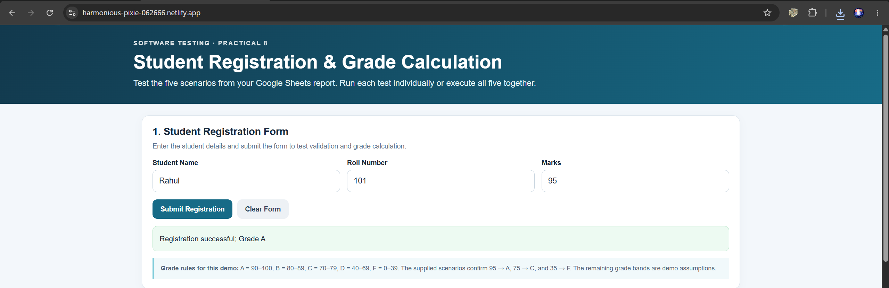
- Scenario ID: TC002
Scenario: Verify grade calculation for 75 marks
Test Steps:
- Enter student name
- Enter roll number
- Enter marks
- Submit the form

Test Input: Name: Rahul; Roll No: 101; Marks: 75
Expected Result: Registration successful; Grade C
Actual Result: Registration successful; Grade C
Status: Pass
Screenshots:
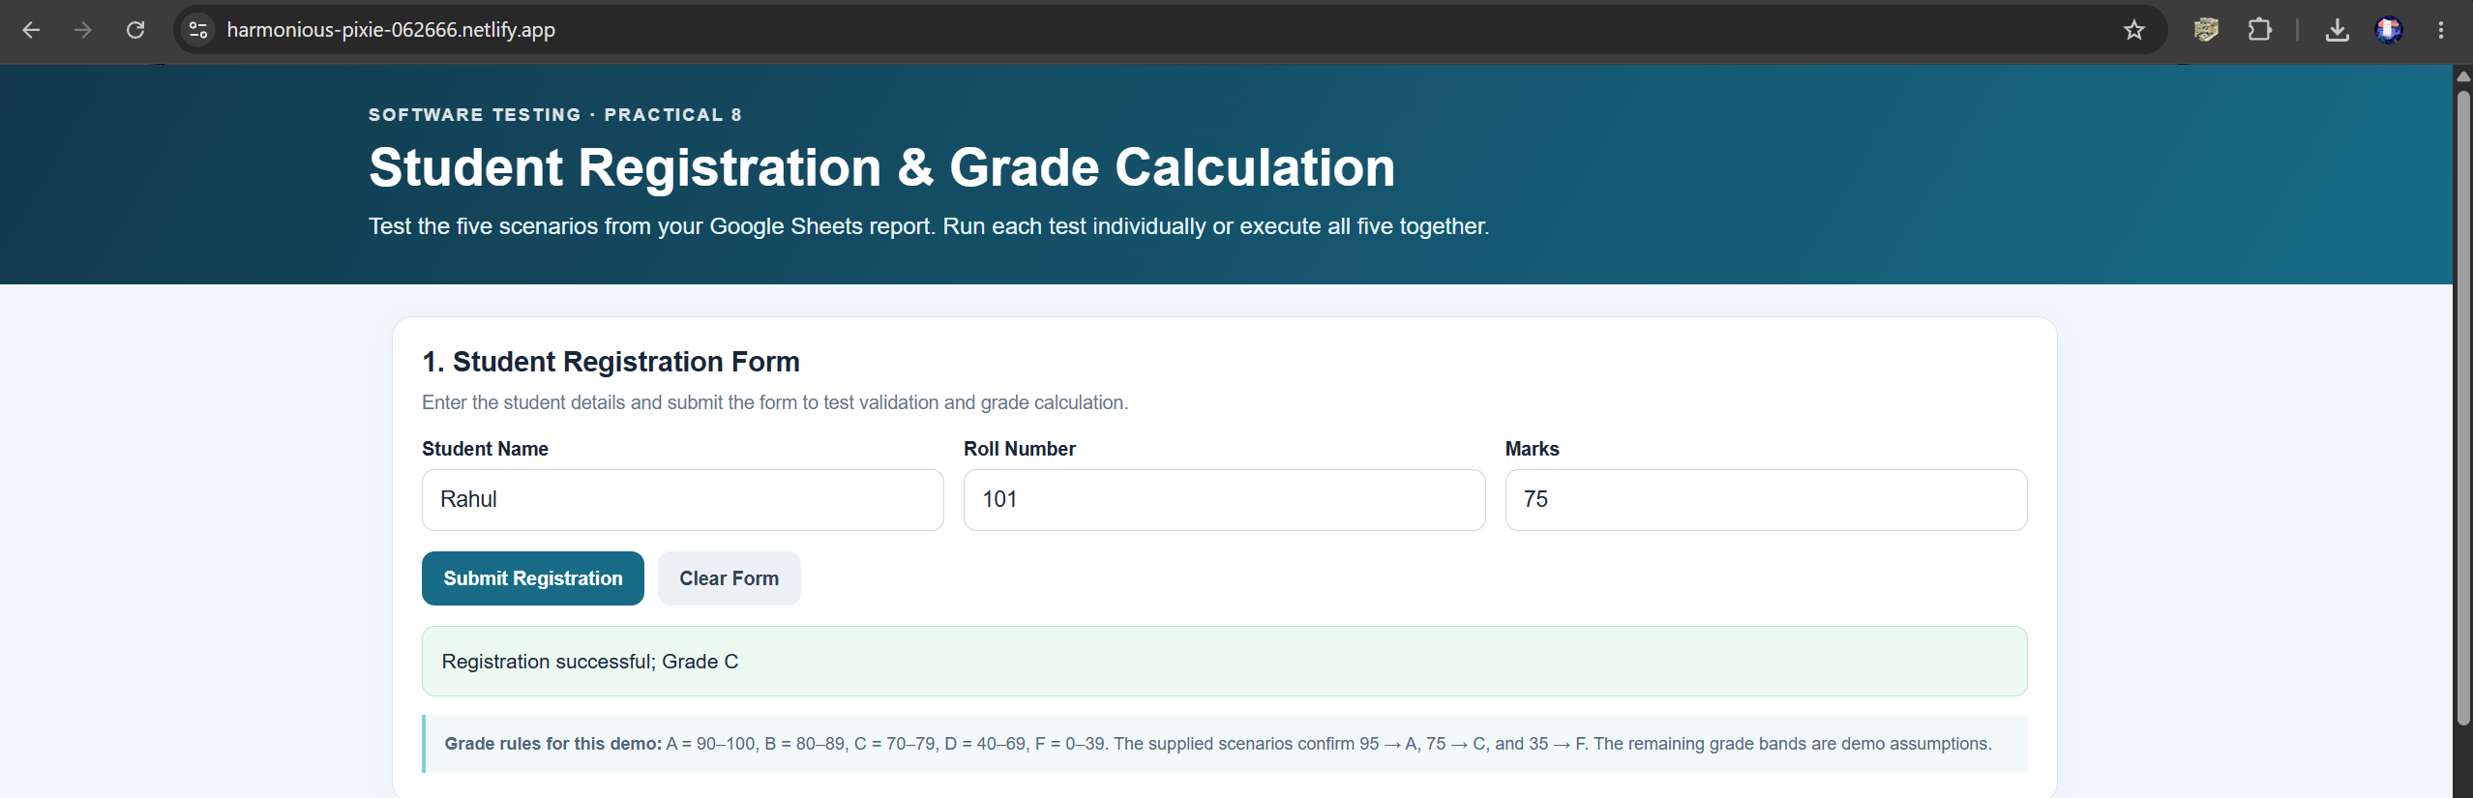
- Scenario ID: TC003
Scenario: Verify handling of negative marks
Test Steps:
- Enter student name
- Enter roll number
- Enter negative marks
- Submit the form

Test Input: Name: Rahul; Roll No: 101; Marks: -5
Expected Result: Invalid marks
Actual Result: Invalid marks
Status: Pass
Screenshots:
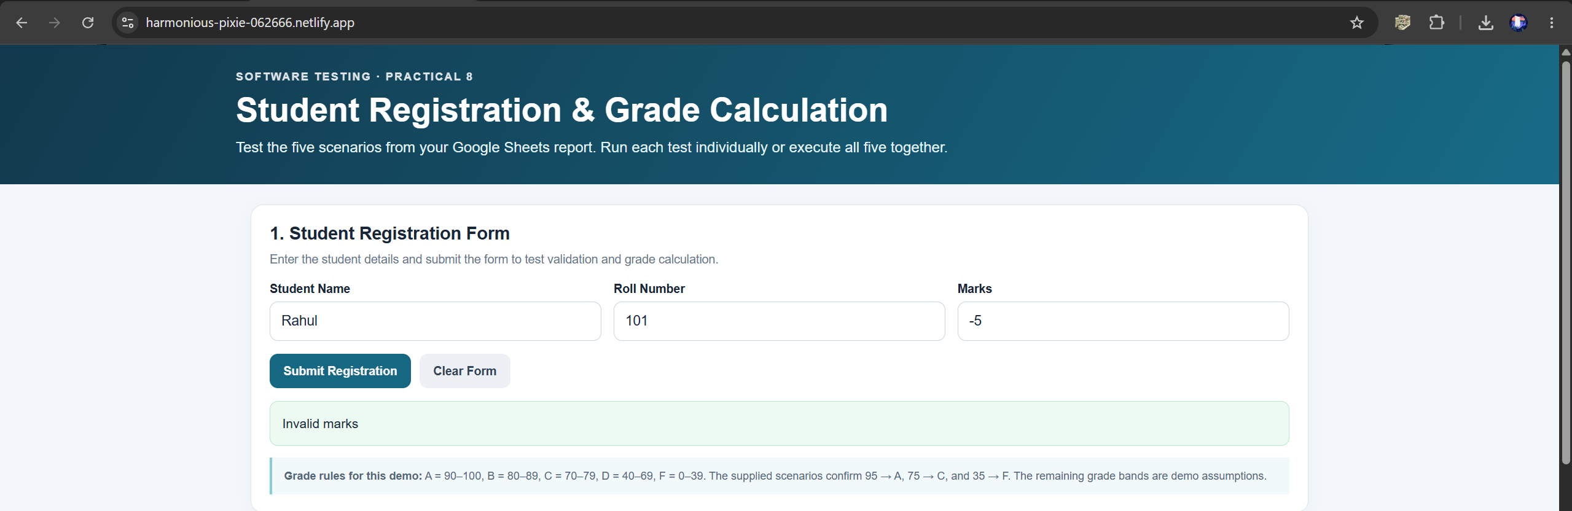
- Scenario ID: TC004
Scenario: Verify handling of a blank student name
Test Steps:
- Leave the student name blank
- Enter roll number
- Enter marks
- Submit the form

Test Input: Name: Blank; Roll No: 101; Marks: 75
Expected Result: Student name cannot be blank
Actual Result: Student name cannot be blank
Status: Pass
Screenshots: 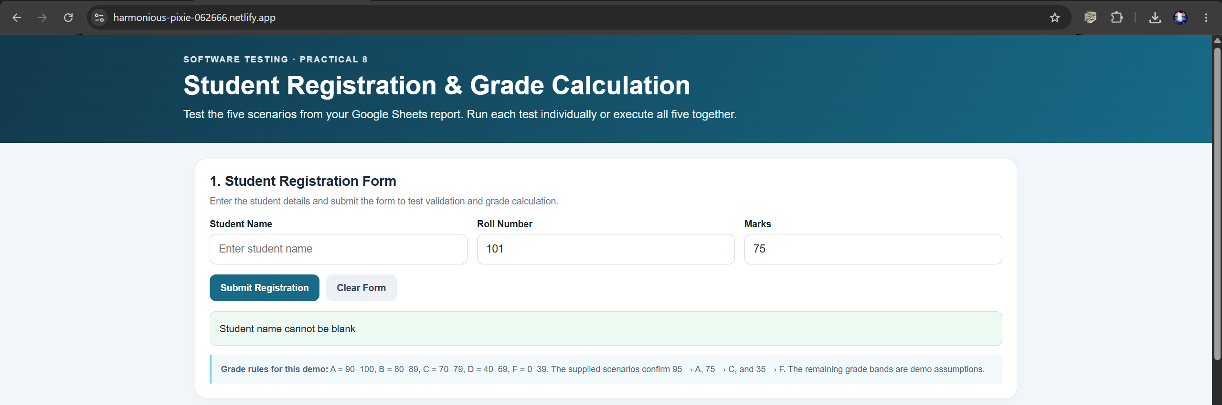
- Scenario ID: TC005
Scenario: Verify grade calculation for 35 marks
Test Steps:
- Enter student name
- Enter roll number
- Enter marks
- Submit the form

Test Input: Name: Rahul; Roll No: 101; Marks: 35
Expected Result: Registration successful; Grade F
Actual Result: Registration successful; Grade F
Status: Pass
Screenshots:
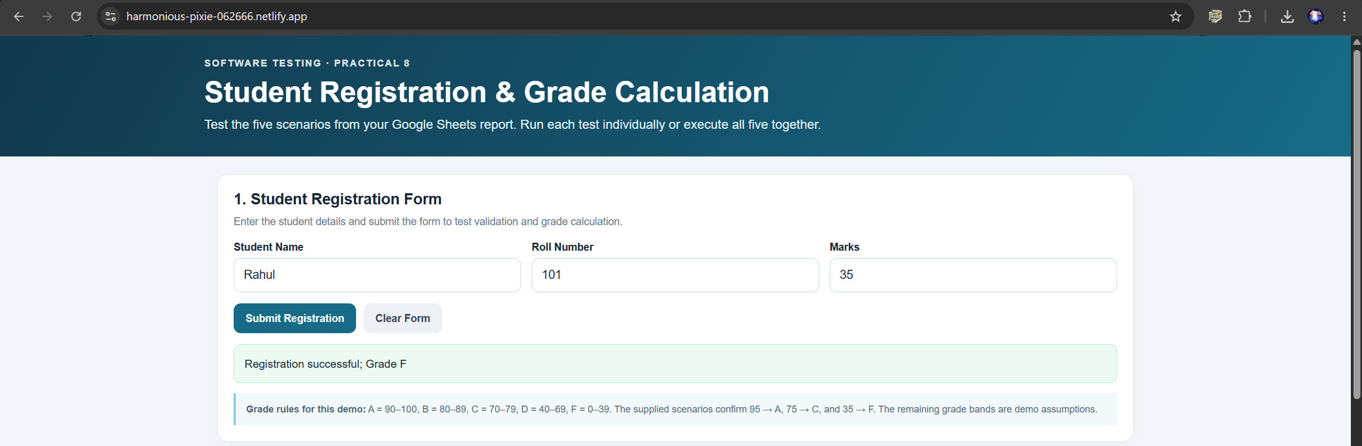
- Summary Of Test Results:
Total Test Cases | 5
Passed | 5
Failed | 0
Pass % | 100%
- Conclusion and Recommendations:
Pass Rate: 100%. All five test cases behaved as expected: valid marks (95, 75, 35) registered the student with the correct grade, and invalid input (negative marks, blank student name) was rejected with a clear message.
- Issues Found
No issues were found during this round of testing.
- Recommendations
- Add boundary-value tests for each grade cut-off (e.g. 40, 50, 60, 70, 80, 90) to confirm grades change at the correct mark.
- Add tests for marks above 100 and for non-numeric marks (e.g. letters) to confirm they are rejected as invalid.
- Add a test for a blank roll number to cover all required fields.
- Bug Reports:
No bugs were reported. All test cases passed, so no bug report was raised.

